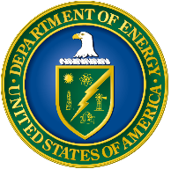
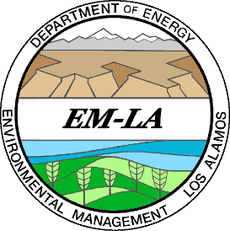
Agenda

Virtual Public Meeting
Individual Permit for Storm Water
at Los Alamos National Laboratory
Issued by the U.S. Environmental Protection Agency
National Pollutant Discharge Elimination System

November 30, 2021
2-4 p.m. MT

2:00 p.m. Introduction & Meeting Guidelines Kate Keenan, N3B
Regulatory & Stakeholder Interface

2:05 p.m. Welcome David Nickless, EM-LA
Director, Office of Completion Project Delivery

2:10 p.m. Communities for Clean Water Update Rachel Conn, Communities for
Clean Water

2:25 p.m. Overview of Individual Permit & Amanda White, N3B/T2S Program
Copper Site-Specific Water Quality Manager, Watershed Monitoring
Criteria & Technical Services

2:45 p.m. Monitoring Year 2021 Sample Results Karly Rodriguez, N3B/T2S Project
Manager, Watershed Monitoring

3:15 p.m. Control Measure Construction Update Grayson Vogel, N3B/T2S Project
Engineer, Technical Services
3:30 p.m. Questions and Answers

Produced by N3B Los Alamos, the Los Alamos Legacy Cleanup Contractor, on behalf of DOE’s Environmental Management Los Alamos Field Office.

